**ssignment 6 Due Date 05/16/21**

**In this assignment, you are required to create the scripts in your Fedora Server Virtual Machine, logged in with ssh-user, insert the picture of the scripts code in the “Answer” section, and upload the Word document to Blackboard**

1- Open the file lab3 located in the labs directory and create a script that prompts the user to enter name, address and phone #. All entered details are directed to file "info.txt" in the same directory. Every time you execute the file will add the information to the end of info.txt

When display info.txt, it should look like this example:

Name: John Smith

Address: 31-10 Thomson Ave.

Phone: 718-482-0000

Answer: [picture of the code]

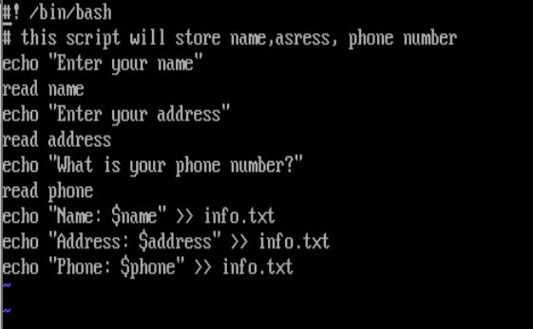

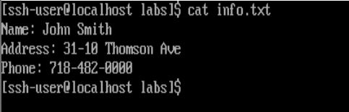

2- Open the file lab4 located in the labs directory and create a script to display the logged in user name and user UID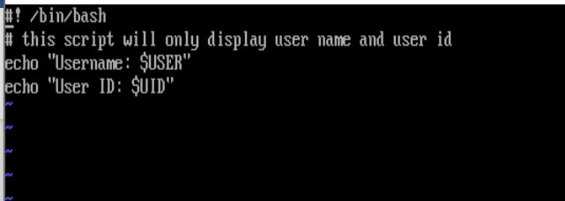

When you execute lab2, the output should look like this example:

Hint: Assign variables with Environment variables value

Answer: [picture of the code]



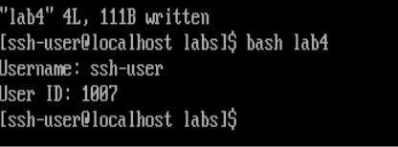

3- An organization pays staff on the 25th day of every month if it falls in the weekdays. Open the file lab5 inside labs directory and create a script to display today’s date and determine if it is a payday or not.

Insert pictures for the code and the output when lab4 executed. Then submit on Blackboard

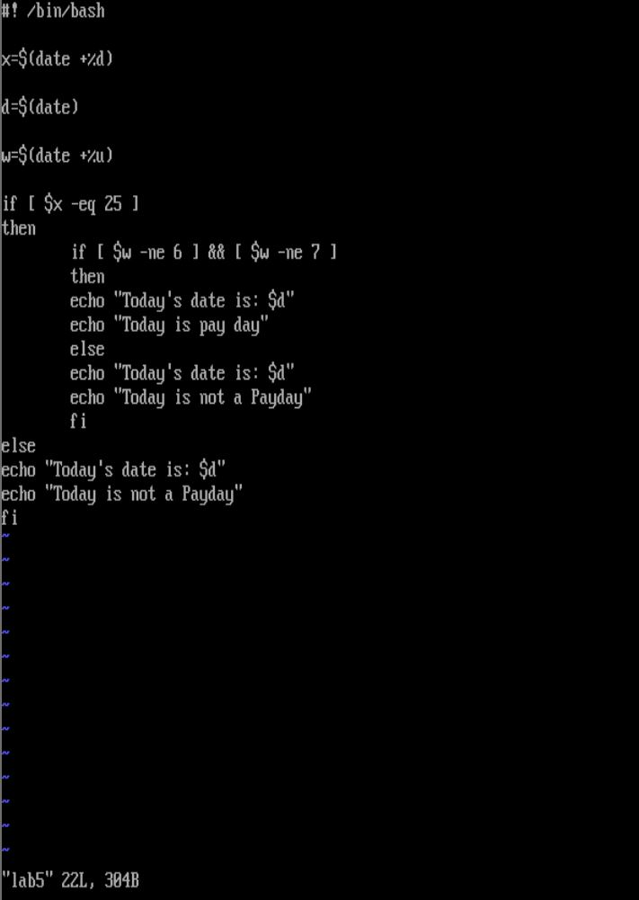

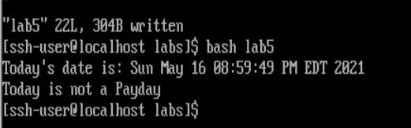

The output examples

Today’s date is: Tue 21 Jul 2020 5:33:34 PM EDT

Today is not a payday

OR

Today’s date is: Fri 25 Jul 2020 5:33:34 PM EDT

Today is a payday

**Hint:**

- Use variables for date +%u (day of the week 1..7) and date +%d (the day of the month 1..31)

- Use && in if statement or nested if statement